

SRINIVASA RAMANUJAN INSTITUTE OF TECHNOLOGY

(AUTONOMOUS)

(Affiliated to JNTUA, Accredited by NAAC with ‘A’ Grade, Approved by AICTE, New Delhi & Accredited by NBA (EEE, ECE & CSE)

Rotarypuram Village, BK Samudram Mandal, Ananthapuramu-515701

Department Of Computer Science & Engineering (Data Science)

(B.Tech program accredited by NBA)

**SRINIVASA RAMANUJAN INNOVATIVE TECHNO PORTAL**

Academic Year : 2023-2024 Year & Sem : IV-II

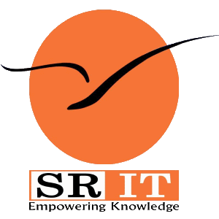

1 .Hospital

2. Donar

3. User / Patient

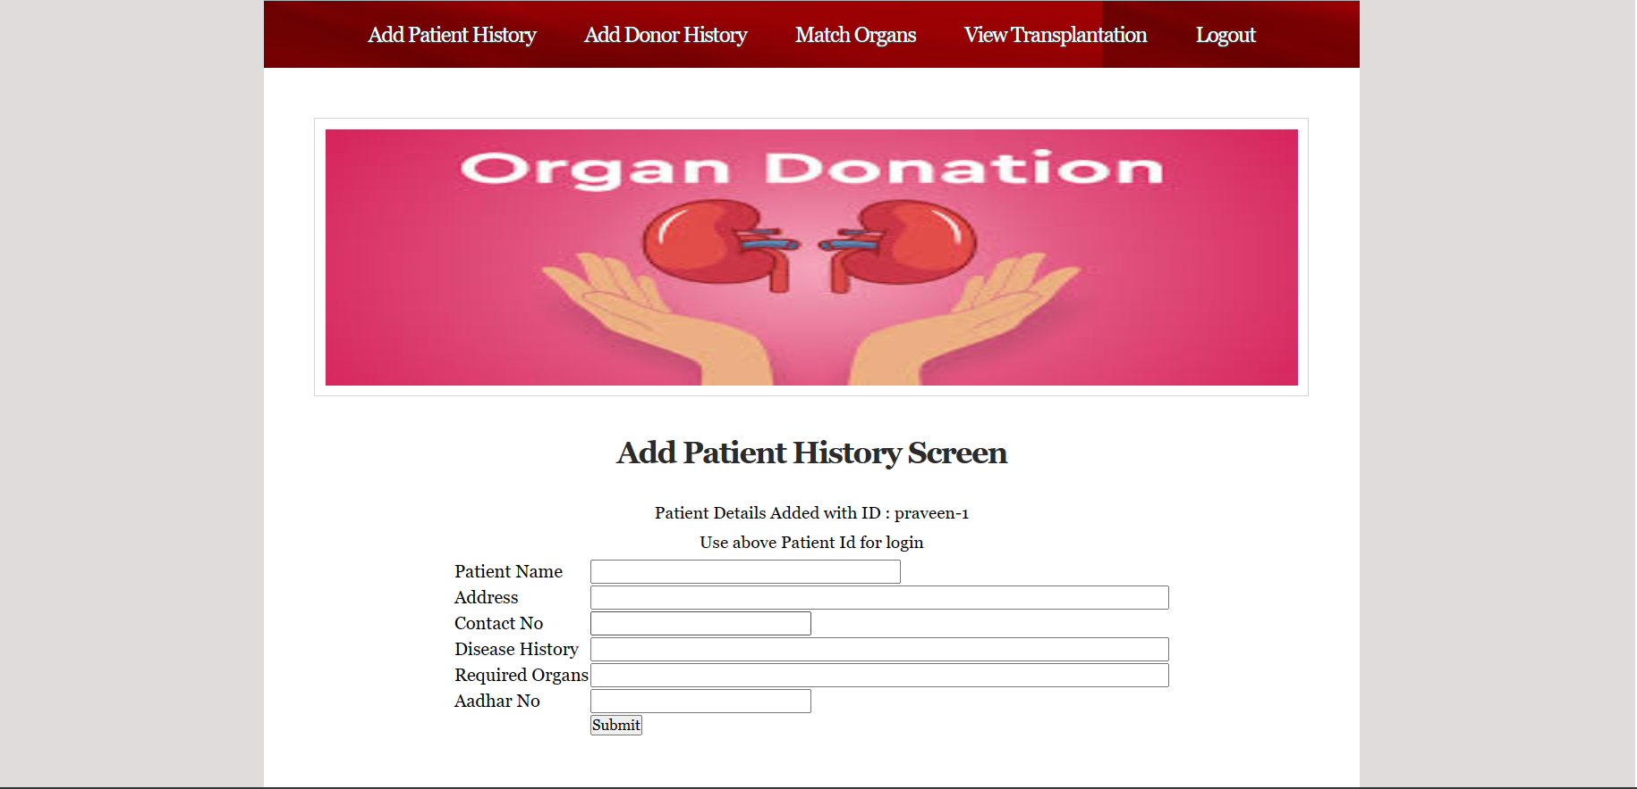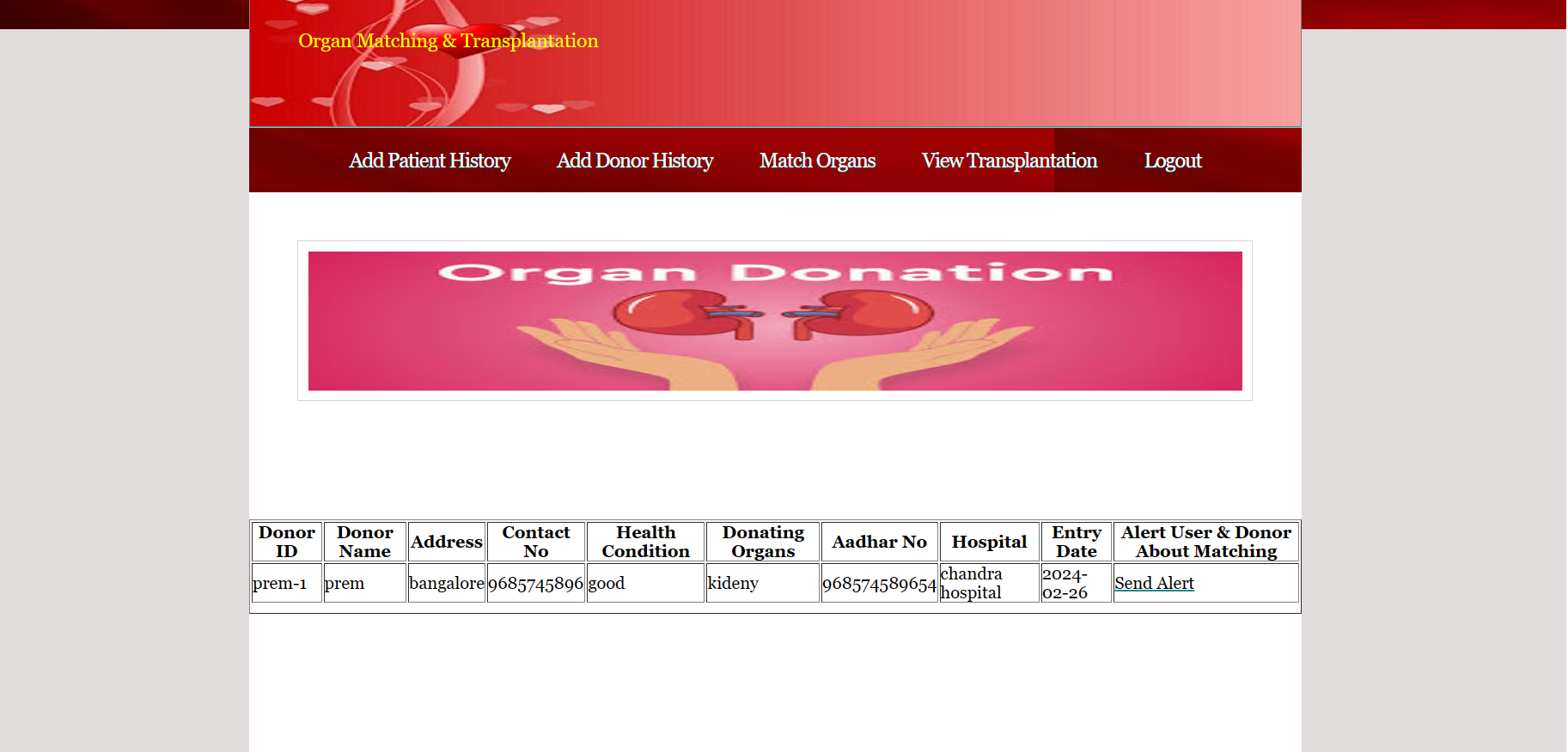

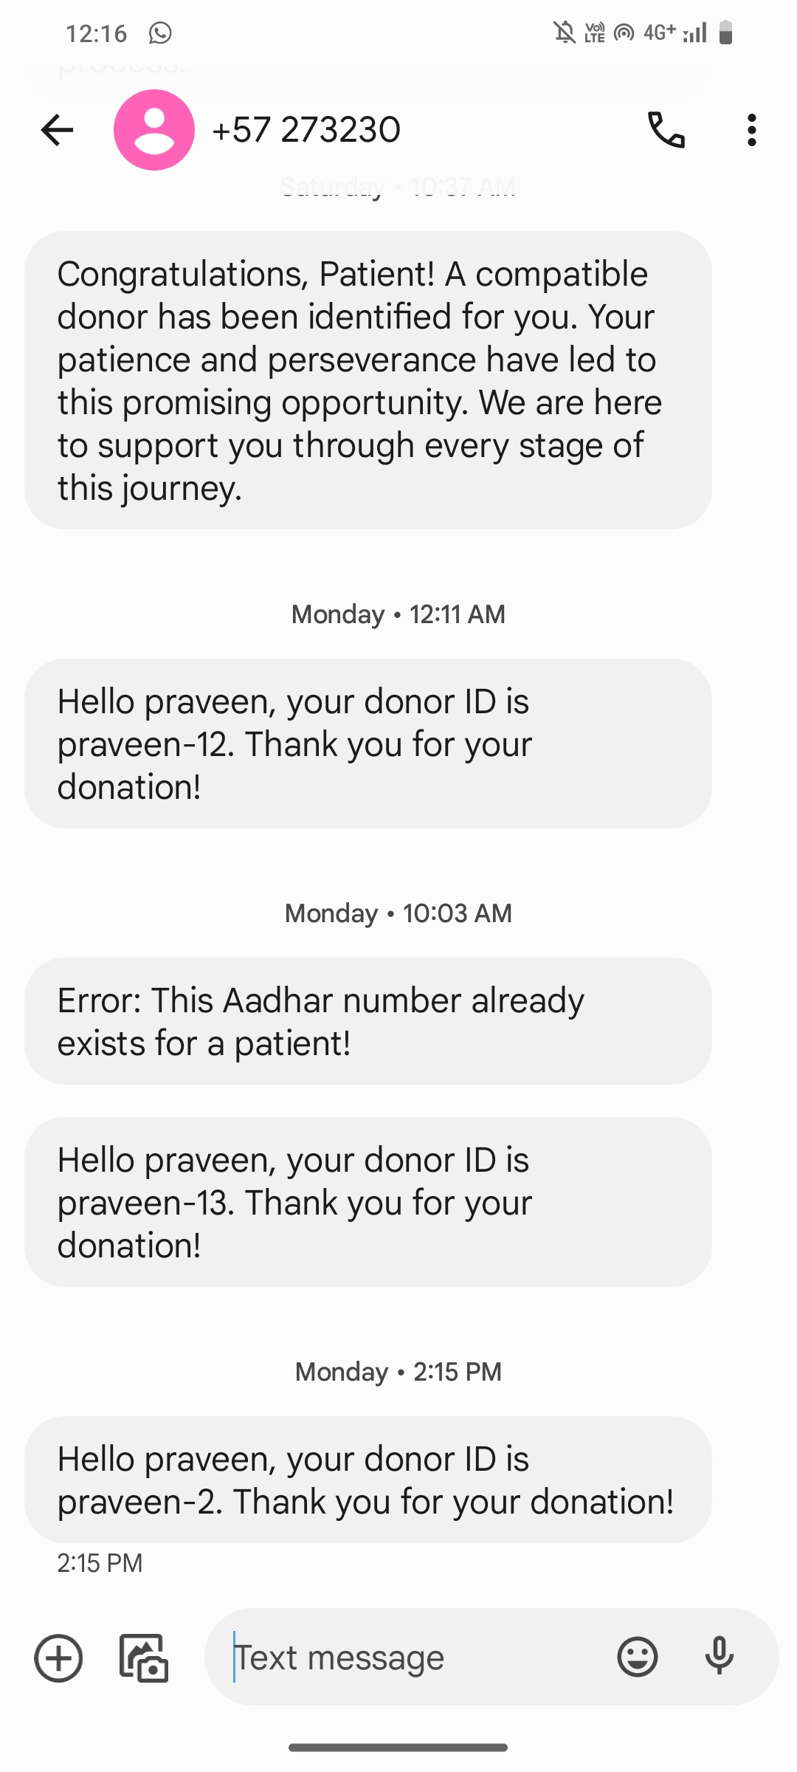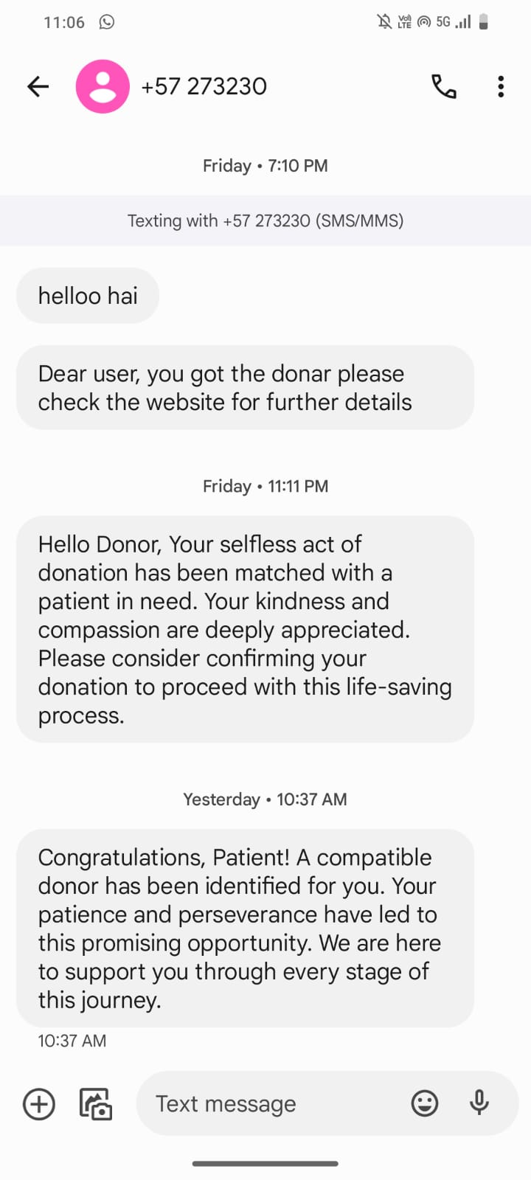

**BATCH NO : A-02**

* **Sujitha P**

**204G1A3253**

* **Laikha Firdos S**

**204G1A3221**

* **Praveen Reddy Y**

**214G5A3203**

The proposed system focuses on leveraging blockchain technology,specifically Ethereum Blockchain, to create a Decentralized Application for efficient organ donation and transplant system. Through this method the challenges with which the existing organ transplant system faced are expected be overcome. The difficulties involve the poor communication between donors and the recipients, illegal organ business and also more cost for the transplantation and urgent recipient needs.

1.Improves Scalability

2.Can generate Unique ID for both patient and Donar.

3.Send Alert messages, when organ matched.

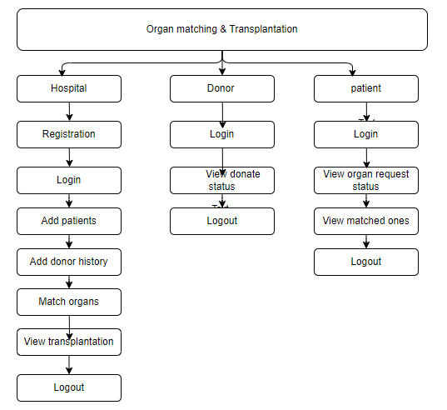

Organ Matching and Transplantation using Blockchain revolutionizes healthcare data management,ensuring security,transparency, and efficiency. Through decentralized systems and smart contracts, it enhances data security, streamlines donor-patient matching, and promotes trust in healthcare services.

The Existing system uses centralized servers to store healthcare data, which has some drawbacks. These servers can be easily targeted by hackers, leading to breaches where sensitive information is accessed without permission. Admins also have the power to change data, which can undermine its reliability. Server failures can cause interruptions in service, and users don't always know if their data is safe. Moreover, there's a risk of data theft by malicious actors, which can compromise patient privacy.

1. Small cap of data can be stored.
2. HyperLedger Fabric uses high gas amount

ORGAN MATCHING AND TRANSPLANTATION USING BLOCKCHAIN

CONCLUSION

MODULES

PROPOSED SYSTEM

In the proposed system we have mainly focused on the importance of the blockchain technology in the organ matching and transplant by ensuring all the aspects like transparency, security where an id is provided to each user, and efficient way for finding the organ. The proposed system also overcomes the challenges which are faced in the existing systems like lack of proper communication between the users and also it reduces the gas amount. The IPFS technology is used to generate a unique ID which can be immutable thereby enhancing the security of the information.

MODULES DESCRIPTION

* The Hospital Module, facilitates hospital registration and secure login processes. Hospitals can add patients, manage donor history, match organs for transplantation, and view transplantation details. Proper logout ensures secure access management.
* The Donor Module allows donors to log in, check donation status, and securely log out.
* Patients can view organ status upon logging in, match organs for transplantation, and securely log out ensuring confidentiality.

OUTPUTS

FLOW CHART

EXISTING SYSTEM

ADVANTAGES OF PROPOSED SYSTEM

LIMITATIONS OF EXISTING SYSTEM